Github URL
https://github.com/WeiTeik/6006CEM-ML

Regression Dataset
https://www.kaggle.com/datasets/yasserh/wine-quality-dataset

Classification Dataset
https://www.kaggle.com/datasets/blastchar/telco-customer-churn

Total Word Count

1.0 Introduction
Machine learning (ML) plays a vital role in solving real-world problems through predictive data analysis and intelligent automation. The report goes over two supervised learning tasks, regression and classification, using different datasets and modelling approaches. The first task is to estimate continuous quality scores based on the physicochemical properties of Portuguese "Vinho Verde" red wine samples. The second task involves using the Telco Customer Churn Dataset from IBM to predict whether a telecom customer will discontinue their service based on demographics, contracts, and service-related factors. ML and deep learning models are implemented and compared for each task to evaluate predictive performance and highlight the strengths and limitations of both.

1.1 Problem Statement
This project uses the Wine Quality Dataset for regression. The primary objective is to predict the quality score of Portuguese "Vinho Verde" red wine based on its acidity, sugar content, sulphates, and alcohol concentration. Several challenges face this dataset, including an uneven distribution of quality ratings and varying numeric scales across chemical features that need to be standardised. The task is to model the relationship between these input variables and a continuous target variable. To evaluate performance differences in predictive accuracy and generalisation, regression approaches like Random Forest Regression are combined with a deep learning model using a feedforward neural network.
In the classification task, the Telco Customer Churn Dataset is used to predict whether a telecom customer will discontinue their service based on demographics, contracts, and usage. There are challenges with this dataset, including class imbalance between churned and non-churned customers and the presence of both categorical and numerical features that need to be encoded and normalised. The classification problem is addressed using two models-a Random Forest Classifier as a traditional ML method and a Feedforward Neural Network as a deep learning approach- to compare their effectiveness in identifying churn patterns and improving customer retention prediction accuracy.

1.2 Existing approaches and their results
Previous studies on the Wine Quality Dataset have applied a range of regression and classification algorithms to predict wine quality based on its physicochemical properties. According to analyses on the UCI Machine Learning Repository and Kaggle, traditional models such as Linear Regression, Support Vector Regression (SVR), and Random Forest Regressor are among the most commonly used methods (Cortez et al., 2009). Random Forest models often outperform simpler linear models due to their ability to capture nonlinear relationships between chemical features and wine quality. Several researchers have also experimented with Feedforward Neural Networks, achieving slightly higher predictive accuracy when hyperparameters are tuned appropriately, though at the cost of longer training times and higher computational demand. In most cases, Random Forest and ensemble-based models achieve an R² score in the range of 0.65–0.75, indicating good predictive power but limited performance due to class imbalance and subjectivity in human quality ratings (Kaggle, 2021).

For the Telco Customer Churn Dataset, multiple studies have explored machine learning approaches to predict customer attrition in telecommunications. Traditional classification algorithms such as Logistic Regression, Decision Trees, and Random Forest Classifiers have demonstrated strong baseline performance (Samples, T., 2019). Ensemble techniques like Gradient Boosting and XGBoost have further improved model accuracy and recall, reaching performance levels between 78% and 85% (Kaggle, 2017). Deep learning methods, including Feedforward Neural Networks, have also been successfully implemented to enhance churn prediction accuracy by capturing complex feature interactions, especially after addressing data imbalance and scaling issues. Overall, prior research suggests that combining data preprocessing techniques—such as feature scaling, one-hot encoding, and oversampling—with ensemble and neural network models yields the most reliable churn prediction results.

1.3 Similarities and differences

2.0 Regression Implementation

2.1 Data Analysis
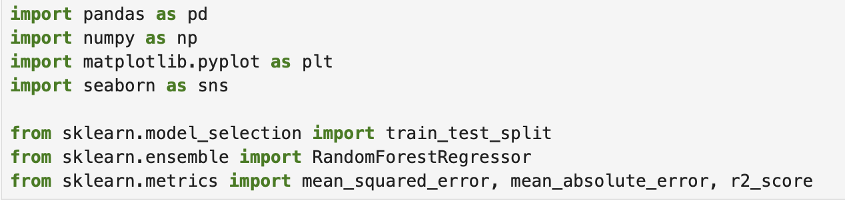

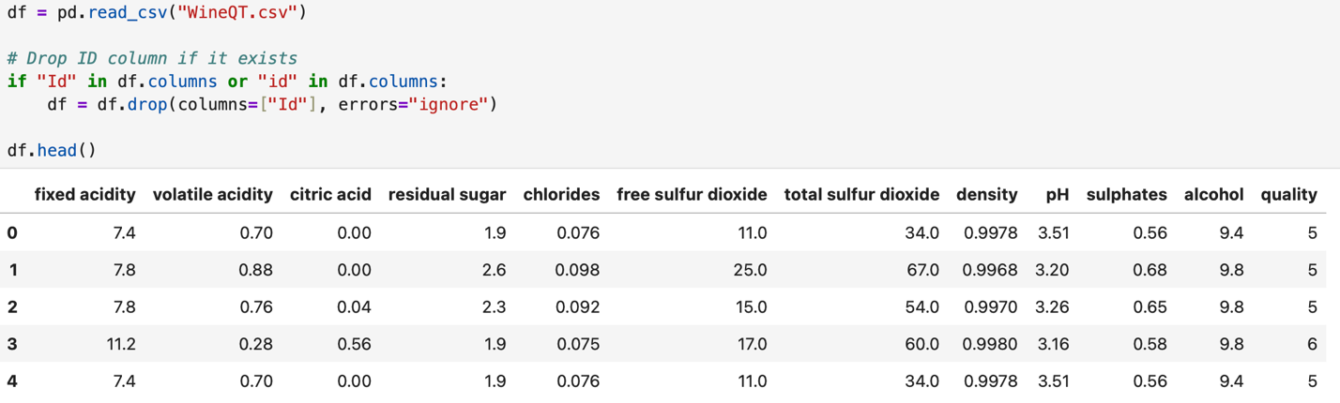

2.2 Exploratory Data Analysis (EDA)

2.3 Data Preprocessing

2.4 Applied Machine Learning Algorithm

2.5 Model Tuning

3.0 Classification Implementation

3.1 Data Analysis

3.2 Exploratory Data Analysis (EDA)

3.3 Data Preprocessing

3.4 Applied Machine Learning Algorithm

3.5 Model Tuning

4.0 Result

4.1 Regression

4.1.1 Analysis and Evaluation

4.1.2 Model Prediction

4.2 Classification

4.2.1 Analysis and Evaluation

4.2.2 Model Prediction

4.3 Conclusion

5.0 References

6.0 Appendix
Appendix A Safe Assign Report

